- What are the purposes of language processors?
Language Processors has mainly three purposes,
- bridge gap between Application Domain and Execution Domain
- translation from one language to another
- to detect errors in source code during translation
Or
Translation: Converts high-level programming code into machine language.
Optimization: Enhances the performance of code.
Error Detection: Identifies and reports syntax and semantic errors.
Resource Management: Efficiently manages memory and other resources during program execution.

- What is a language processor?
A language processor is software that bridges a specification or execution gap, typically aborting the generation of the target program if it detects errors in the source program.
Or
A language processor is a software tool that transforms source code written in a programming language into a form that can be executed by a computer, such as machine code, intermediate code, or another high-level language.

- Which are the types of language processors?
1.Language Translators - A Language translator bridges an execution gap to the machine language of a computer system.
2. Detranslator – A detranslator bridges the same execution gap as the language translator, but in the reverse direction.
3. Preprocessor – A preprocessor is a language processor which bridges an execution gap but is not a language translator.
4. Language Migrator – A Migrator bridges the specification gap between two PLs.

Or

Compiler
Translates high-level programming languages into machine language. Compilers analyze the entire source code and generate executable machine code for a CPU.
Interpreter
Translates and executes instructions written in a programming or scripting language line by line. Interpreters analyze the source code less than compilers, but the program's overall execution time is slower.
Assembler
Translates . The source program is input to the assembler, which generates object code that the computer can understand

- Explain the phases of language processor.
Phases
There are mainly two phases of language processor which are
1. Analysis phase 2. Synthesis phase
Analysis Phase
The objective of the analysis phase is to break up the source code and imposes into a grammatical structure to create an Intermediate Representation (IR). In addition to it, it also collects information like labels from source code and stores in a symbol table.
Synthesis Phase
The synthesis phase, construct the object code from the intermediate representation and symbol table. Some objectives of this phase includes: 1. Obtain machine code from mnemonics table 2. Check the address of an operand from symbol table 3. Synthesize a machine instruction

- Define Symbol Table.
Symbol table is an important data structure created and maintained by compilers in order to store information about the occurrence of various entities such as variable names, function names, objects, classes, interfaces, etc. Symbol table is used by both the analysis and the synthesis parts of a compiler.

- What is a compiler? Name the two main phases of compiler.
A compiler is a program that translates source code written in a high-level programming language into machine code or intermediate code that a computer can execute.

Two Main Phases of a Compiler:
- Analysis Phase:
  - Breaks down the source code into its structural components.
  - Includes lexical analysis, syntax analysis, and semantic analysis.
  - Outputs an intermediate representation.
  - In addition to it, it also collects information like labels from source code and stores in a symbol table
- Synthesis Phase:
  - Translates the intermediate representation into target machine code.
  - Includes code optimization and code generation.
This ensures the conversion of human-readable code into executable instructions efficiently.

- Explain the phases of compilation.
Lexical Analysis:
- Breaks the source code into tokens (e.g., keywords, identifiers, operators).
- Removes whitespace and comments.
Syntax Analysis:
- Ensures the token sequence follows the grammar of the language.
- Constructs a parse tree to represent program structure.
Semantic Analysis:
- Checks for logical errors (e.g., type mismatches, undeclared variables).
- Produces an annotated parse tree.
Intermediate Code Generation:
- Converts the parse tree into a simplified, machine-independent intermediate representation (IR), like three-address code.
Code Optimization:
- Improves the IR for efficiency, such as removing redundant code or optimizing loops.
Code Generation:
- Translates the optimized IR into machine code or assembly language.
- Allocates memory and registers for variables.
Symbol Table Management:
- Maintains information about identifiers, including their types, scopes, and memory locations.
Error Handling:
Detects and reports errors at each phase and provides recovery mechanisms.

- What is Bootstrapping? Explain the steps.
Bootstrapping is a process in which simple language is used to translate more complicated program which in turn may handle for more complicated program. This
complicated program can further handle even more complicated program and so on.

Steps of Bootstrapping:
- Write a Simple Compiler: Create a basic version of the compiler in another language (e.g., assembly or a different high-level language).
- Compile the First Version: Use this simple compiler to compile a more advanced version of the compiler written in the target language.
- Self-Hosting Compiler: Use the compiled version of the compiler to compile itself.
- Refine and Optimize: Improve the self-hosting compiler for better performance and new features.

- What are the advantages of bootstrapping a compiler?
1. It is a non-trivial test of the language being compiled.
2. Compiler developers only need to know the language being compiled.
3. Compiler development can be done in the higher level language being compiled.
4. Improvements to the compiler's back-end improve not only general purpose
programs but also the compiler itself.
5. It is a comprehensive consistency check as it should be able to reproduce its own
object code.

- What is a cross compiler?
A cross compiler is a compiler capable of creating executable code for a platform
other than the one on which the compiler is running. Example, a compiler that runs
on a Windows 7 PC but generates code that runs on Android smartphone is a cross
compiler.

- What is porting a compiler?
The process of modifying an existing compiler to work on a new machine is often
known as porting the compiler.

- Name some compiler construction tools.

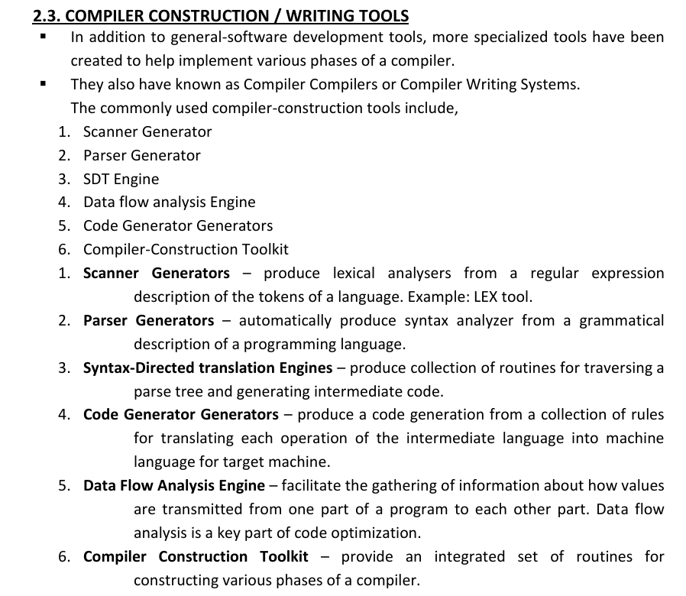
OR

Scanner Generators - Create lexical analyzers using regular expressions (e.g., LEX).
Parser Generators - Generate syntax analyzers from grammar descriptions.
SDT Engines - Build routines to process parse trees and create intermediate code.
Code Generator Generators - Translate intermediate code to machine code.
Data Flow Analysis Engine - Analyze value flow in programs for optimization.
Compiler Toolkit - Provide tools for building all phases of a compiler.

- What is the role of a lexical analyzer?
The main task of the lexical analyzer is to read the input characters of the source program, group them into lexemes, and produce as output a sequence of tokens for each lexeme in the source program.

- Explain the design issues of a lexical analyzer.
Simplicity of design – The separation of lexical and syntactic analyses allows the
compiler designer to simplify at least one of these tasks.
Compiler efficiency is improved – a separate lexical analyzer allows the
designer to apply specialized techniques that serve only the lexical task.
Specialized Input buffering technique for reading input character can speed up
the compiler significantly.
Compiler portability is enhanced – Input device specific peculiarities can be
restricted to the lexical analyzer.

- Name the lexical errors and the recovery actions.
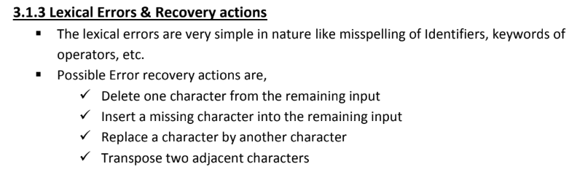
- Explain input buffering.
The lexical analyzer scans the input string from left to right one character at a time. It uses two pointers:
Lexeme_begin_pointer (LBP) and Forward_ptr (FP) to keep track of the portion of the input scanned.
Initially both the pointers point to the first character of the input string.
The forward_ptr moves ahead to search for end of lexeme. As soon as the white space is encountered it
indicates end of lexeme. In the above example as soon as the forward_ptr (FP) encounters a blank space
the lexeme "int" is identified.
At the moment the forward_ptr is located in the blank space. So the forward_ptr will ignore the blank
space and it will move ahead. Then both the Lexeme_begin_ptr (LBP) and the forward_ptr (FP) will be
set for the next lexeme.

- Explain lexical analysis.
The source program is read character by character from left to ri ght and grouped into tokens.
Tokens are the smallest meaningful units in the program, such as keywords, identifiers, operators, literals, and punctuation marks.

Linear analysis is also called lexical analysis or scanning.
The blanks separating the character of tokens are eliminated.

- What are tokens, lexemes, and patterns?
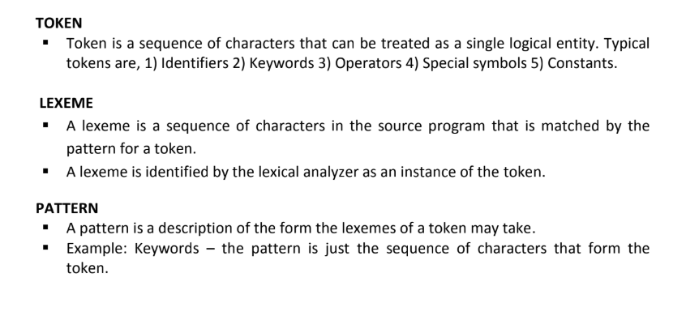
- Explain the format of a token.
The Lexical analyzer produces as output a token of the form,
< Token name, Attribute value >
Where
Token name – is an abstract symbol representing a kind of lexical unit.
Attribute value – an optional attribute value providing additional information to the
parser.

Let C = A + B; is any statement in the source program, the tokens are
<ID, Pointer to ST Entry for C>
<Assign_OP>
<ID, Pointer to ST Entry for A>
<Arith_OP>
<ID, Pointer to ST Entry for B>
- Write regular expressions for the following: (a)Letter (b) Digit (c) identifier (d) operators
Letter: [a-zA-Z]
Digit: [0-9]
Identifier: [a-zA-Z_][a-zA-Z0-9_]*
Operators: [+\-*/=<>]
- What is the LEX tool? How does it work?
lex tool allows to specify lexical analyzer by specifying regular expression to describe patterns and tokens.
- What are three parts of Lex program?

->The three parts of a Lex program are:
- Definition section: Defines regular expression patterns and macros.
- Rules section: Specifies patterns and the actions that correspond to them.
- C code section: Contains user-defined C code that runs alongside the code generated by Lex.

The parts of a Lex program are separated by lines with two percent signs (%%). The first two parts are required, but the third part and the preceding %% line can be omitted.
Here are some more details about each part of a Lex program:
Definition section: The definition section can be empty, but the %% separator is required.
Rules section: The first non escaped space or tab on a line in the translation section signals the start of the action.
C code section: The C code section contains user-defined C code to be executed alongside lex-generated code.

- What is use of yywrap?
yywrap is a function in Lex/Flex that is called when the scanner reaches the end of an input file; it determines whether the scanner should stop processing (default behavior) or continue with additional input.
- What is the use of yylex() function in Lex?
The yylex() function in Lex is the main lexical analyzer function that scans input, matches it against defined patterns, and returns tokens to the parser or calling program for further processing.

- Write LEX programs
- What is syntax analysis?
Syntax analysis is a process that analyzes the structure and meaning of sentences or code: The steps involved in syntax analysis include:
- Tokenization: Breaking down the code into basic elements or tokens
- Rule application: Applying the programming language's syntax rules to the tokens to verify their correct arrangement
- Tree construction: Building a parse tree or abstract syntax tree from tokens if they follow the syntax rules correctly

- What is CFG?
Grammars are used to systematically describe the syntax of programming language
constructs like expressions and statements.

- What is a derivation tree? Is it same as the parse tree?
What is a derivation tree? Is it same as the parse tree?
Yes, a derivation tree is the same as a parse tree:
Definition:
A derivation tree, also known as a parse tree, is a graphical representation of a string's syntactic structure. It shows how to derive a string from a set of production rules.

- What is ambiguous grammar? How do you find out if a grammar is ambiguous?
Ambiguous Grammar: A grammar is ambiguous if a single string can have more than one valid parse tree or derivation.

How to Identify Ambiguity:
Generate a string derivable from the grammar.
Attempt to construct multiple parse trees for the string.
If more than one valid tree exists, the grammar is ambiguous.
- What is left recursion?
Left Recursion: A grammar has left recursion if a non-terminal appears as the leftmost symbol in its own derivation.
Example:
A → Aα | β
Here, A directly derives itself (A → Aα).

Why is it a problem?
Left recursion causes infinite recursion in top-down parsers (e.g., recursive descent parsers).
- What is left factoring?
A technique that transforms a grammar with common prefixes into an equivalent grammar that's suitable for top-down parsing
- Mention the types Of LR Parser
LR parsers are a type of bottom-up parser that analyze deterministic context-free languages in linear time. They are the most general non-backtracking shift-reduce parsing method known. LR parsers can usually recognize all programming language constructs that can be specified by context-free grammars.
There are several types of LR parsers, including:
SLR (1): Also known as simple LR parsing, this is the same as LR(0) parsing, but with a different parsing table.
Canonical LR (1) parser: Also known as a CLR parser, this is a bottom-up parsing algorithm used to analyze and process programming.
LALR parser: This parser has more language recognition power than the LR(0) parser, but requires the same number of states for languages that both parsers can recognize.
Minimal LR (1) parser: A type of LR parser.
Generalized LR parser (GLR parser): A type of LR parser.
- What Are the Problems With Top Down Parsing?

Key Problems:
- Left Recursion:
○ Top-down parsers cannot handle left-recursive grammars.
- Backtracking:
○ Inefficient if backtracking is required to explore multiple parse paths.
- Ambiguity:
○ Cannot handle ambiguous grammars.
- Factoring:
○ Grammar needs to be left-factored to remove common prefixes.
- Lookahead Limitation:
○ LL(1) parsers can only handle grammars that can be parsed with one lookahead token.

- Basic difference between LR(0) and SLR(1)?
LR(0) Parser: It uses only the items without considering any lookahead symbols.
SLR(1) Parser: It extends LR(0) by incorporating lookahead symbols to resolve conflicts.

- What is difference between LR(0) item and LR(1) item?
LR(0) Item: Consists of a production rule and a position marker (dot •) indicating the parsing progress.
LR(1) Item: Extends the LR(0) item by adding a lookahead symbol, which represents the set of input symbols expected after the completion of the production.

- What is FIRST of a grammar? What is FOLLOW of a grammar? How to find them?
In grammar, the FIRST set of a non-terminal symbol is the set of all possible terminals that can appear at the beginning of a string derived from that non-terminal. The FOLLOW set is the set of terminals that can appear immediately after a non-terminal in a grammar's derivation.

To find First
Given the production rule:

A → aB | ε

The FIRST set of A would be:

FIRST(A) = {a, ε}

To find Follow
Given the production rule:

A → aB

The FOLLOW set of B would be:

FOLLOW(B) = {ε} (assuming A is the start symbol)

Or, if we have another rule:

A → aB c

Then:

FOLLOW(B) = {c}

- How to eliminate left recursion?
Left recursion occurs when a grammar rule has the form:

A → Aα | β

where A is a non-terminal, α is a string of terminals and/or non-terminals, and β is a string of terminals and/or non-terminals.

To eliminate left recursion, you can apply the following steps:

1. Identify the left-recursive rule(s).
2. Convert the rule to a right-recursive form using the following transformation:

A → Aα | β

becomes:

A → βA'
A' → αA' | ε

where A' is a new non-terminal.

Example:

Original grammar:

E → E + T | T

Left-recursive rule:

E → E + T

Converted grammar:

E → TE'
E' → +TE' | ε
In the converted grammar, the left-recursive rule has been eliminated.

- Name the various bottom-up parsers.
Shift-Reduce Parser
Operator Precedence Parser
Simple LR (SLR)
Canonical LR (CLR)
Lookahead LR (LALR)
- Explain the steps to construct the operator precedence parser.

- Which are the conflicts in bottom-up parsers?

1. Shift-Reduce Conflict: This occurs when, at a given step, the parser has to decide whether to perform a shift or a reduce action, but both actions are possible.
2. Reduce-Reduce Conflict: This occurs when the parser faces a situation where there are multiple reduction options for the symbols at the top of the stack.
3. Shift-Reduce Conflicts in LR Parsers: In LR parsers, a shift-reduce conflict happens when,at a specific point in the input, it’s unclear whether to shift the next symbol or to apply a reduction rule.

- What is LL(1) parser?
An LL(1) parser is a type of top-down parser used in compiler design to parse context-free grammars. It processes the input from left-to-right (L) and constructs a leftmost derivation (L) with a lookahead of 1 token (1).

- What is intermediate code?
Intermediate code is a machine-independent representation of a program that acts as a bridge between source code and machine code

- What is syntax tree?
A syntax tree, also known as a parse tree, is a tree-like data structure that represents the syntactic structure of a programming language construct, such as an expression, statement, or program.

- Generate syntax tree for: a=b* -c + b * -c
- What is DAG?
A DAG (Directed Acyclic Graph) is a specialized graph structure in which:
Directed: Every edge in the graph has a direction, meaning it goes from one vertex (node) to another specific vertex.
Acyclic: The graph contains no cycles, i.e., there is no path that starts and ends at the same vertex while following the direction of edges.

- What is three address code?
Three Address code is a sequence of statements of the general form x = y op z, where x, y
and z are names, constants and op stands for operator.

- Explain the implementation of three address code.

Steps to Implement TAC:
Source Code Analysis: The compiler first analyzes the source code, parsing it into an Abstract Syntax Tree (AST).
Generation of TAC: The compiler traverses the AST and generates TAC instructions for each operation in the source code, breaking down complex expressions.
Optimization: TAC allows for various optimizations, such as constant folding, dead code elimination, and common subexpression elimination, making the final code more efficient.
Intermediate Representation: TAC acts as an intermediate form between the high-level source code and the machine code. It is easier to manipulate for optimization and generation of machine code.

- What is backpatching?
Backpatching is a technique used in compiler design during the intermediate code generation phase. It simplifies the process of generating intermediate code for control flow statements (like if, else, while, goto) by delaying the final resolution of jump targets until sufficient information is available.
- What are activation trees?
Activation Trees represent the dynamic behavior of procedure calls during program execution. Each node in the tree corresponds to an activation record of a procedure, and the edges represent the caller-callee relationships.
- Explain the subdivision of runtime memory.
The memory used during execution is generally subdivided into several regions, each serving a different purpose. These subdivisions help organize the memory for efficient use and proper management.
- What is activation record? Which are the fields of activation record?
Activation Record: A data structure containing information about a function call, such as local variables, return address, and saved registers.
fields of activation record:
Return Address
Control Link (Dynamic Link)
Access Link (Static Link)
Saved Machine State
Actual Parameters
Local Variables
Temporary Values
Return Value
Frame Pointer (FP)
- Which are the different methods of storage allocation?
1. Static Storage Allocation
2. Dynamic Storage Allocation
3. Stack-Based Allocation

- Name the data structures used to implement symbol table.
- Hash Tables
- Binary Search Trees
- Arrays
- Linked Lists
- Prefix Tree

- What is code generation?
The final phase in compiler model is the code generator.
▪ It takes as input an intermediate representation of the source program and produces as
output an equivalent target program.

- What are the issues in the design of a code generator.
Correctness: Ensuring the generated code is semantically correct.
Instruction Selection: Mapping intermediate representations (IR) to appropriate machine instructions.
Register Allocation: Efficiently using the limited number of registers in the target machine.
Instruction Scheduling: Ordering instructions to avoid stalls and exploit parallelism.
Memory Management: Handling stack, heap, and global variables effectively.
Handling Control Flow: Generating code for loops, conditionals, and jumps.
Optimization: Balancing speed, size, and power efficiency in the generated code.
Target Machine Constraints: Adapting to RISC, CISC, or stack-based architectures.

- Explain the basic block partitioning algorithm.
Basic Block Partitioning Algorithm

Step 1: Identify Leaders

Identify the leaders in the code, which are the first instructions of basic blocks. Leaders are typically:

- The first instruction of the program
- The target of a branch or jump instruction
- The instruction immediately following a branch or jump instruction

Step 2: Find Basic Blocks

Starting from each leader, scan the code sequentially to find the basic blocks. A basic block is a sequence of instructions that:

- Starts with a leader
- Contains no branches or jumps (except for the last instruction)
- Ends with a branch, jump, or return instruction (or the end of the program)

Step 3: Partition the Code

Partition the code into basic blocks based on the leaders and block boundaries identified in Steps 1 and 2.

- What are leaders in the basic blocks?
The leader of a basic block is the first instruction in the block. It is the instruction that is executed immediately after a control flow change, such as a branch or jump.

Properties of Leaders

Leaders have the following properties:

1. Unique: Each basic block has a unique leader.
2. First instruction: The leader is the first instruction executed in the basic block.
3. Control flow target: The leader is the target of a control flow change, such as a branch or jump.

- What is a flow graph?
The nodes of the flow graph are basic blocks and the first block is designated as a Initial block
▪ There is an directed edge from the basic block B1 to B2, iff B1 is a predecessor of B2.

- What is next-use information? How is it useful?
Next-use information is a data flow analysis technique that indicates when a variable will be reused in a program. It's used in compiler design to improve the performance of a compiled program by optimizing register allocation and reducing memory accesses.
Here are some ways next-use information is useful:
- Register allocation
Next-use information helps decide whether to keep a computation in a register or move it to a variable so the register can be reused.
- Dead-code elimination
Next-use information can help identify unreachable code that can be eliminated.
- Variable selection
Next-use information can help select variables to keep in registers for quicker access

- Explain the code generation algorithm.

- What are register and address descriptors?
Register descriptor: keeps track of variables whose current values are in register.Initially they are empty.
Address descriptor: keeps track of location or locations where current value of variable is found.location can be register,stack,memory location.

- What is peephole optimization?
Peephole optimization is a technique to improve a program's performance by analyzing and replacing short instruction sequences (called the peephole) with shorter or faster alternatives.

- Explain the various methods of peephole optimization.
1. Redundant Loads and Stores ○ Removes unnecessary load/store instructions where the same value is loaded or stored repeatedly.
2. Unreachable Code Removal ○ Eliminates code that can never be executed due to logical flow or conditional jumps
3. Flow-of-Control Optimization ○ Simplifies sequences of jumps or branches to improve control flow.
4. Algebraic Simplifications ○ Simplifies arithmetic expressions using mathematical identities.
5. Reduction in Strength ○ Replaces expensive operations with cheaper equivalents.
- Explain the methods of code optimization.
1. Common Subexpression Elimination : Avoid redundant calculations of the same expression.
2. Copy Propagation ● Goal: Replace a variable with its value where possible, making some code redundant.
3. Dead Code Elimination ● Goal: Remove code that does not affect the program's outcome.
4. Constant Folding ● Goal: Precompute constant expressions during compilation. Example: Before: a = 3.14 / 2 After folding: a = 1.57
- What is loop jamming?
Loop jamming is a compiler optimization technique where two or more loops that iterate over the same range are combined into a single loop to reduce loop overhead and improve performance.

- What is loop unrolling?
Loop unrolling reduces CPU time by minimizing or eliminating loop exit checks.

- What is DAG representation of basic blocks?
The DAG (Directed Acyclic Graph) representation of a basic block is a graphical representation used in compiler design to express the data flow and dependencies of computations within a basic block.

- What are the applications of DAG?
1. We can automatically detect common sub expressions.
2. We can determine which identifiers have their values used in the block.
3. We can determine which statements compute values that could be used outside the block

